February 2020

Suggested Tweets for HIP Partners focused on the Galvanizing Commitment brief

Quick Content! All Suggested Tweets Ready to be Posted

Monthly, we send you an updated social media guide on the High Impact Practices in Family Planning (HIPs) with the purpose of (1) increasing awareness and use of the HIP briefs, and (2) generating traffic on the HIP website. Please share!

Tweet me!

When policymakers commit to #familyplanning, the results are clear. More families have access to modern contraceptives and can choose what’s best for them.
https://www.fphighimpactpractices.org/briefs/galvanizing-commitment/
#HIPs4FP #WorldDayofSocialJustice
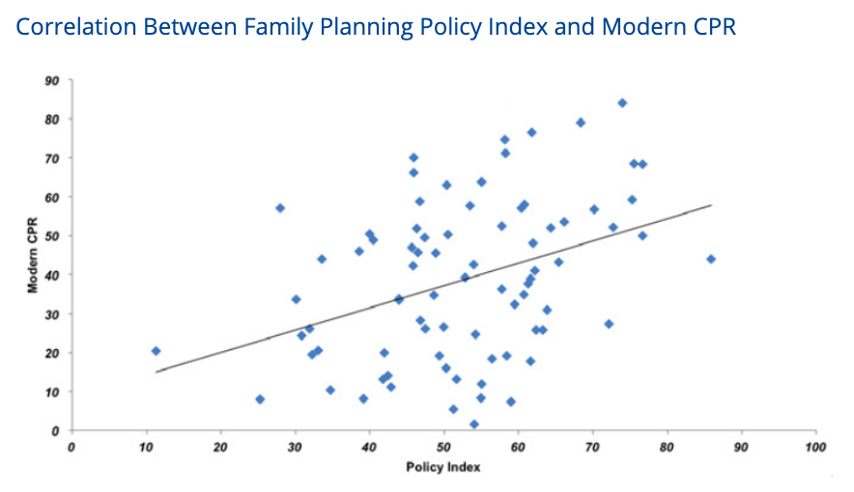
This month, we observe the #WorldDayofSocialJustice. Learn how galvanizing commitment for #familyplanning can close the inequalities gap:
https://www.fphighimpactpractices.org/briefs/galvanizing-commitment/ #HIPs4FP
How can galvanizing commitment for #familyplanning strengthen countries and communities? India, Kenya, Bolivia, and other countries will tell you:
https://www.fphighimpactpractices.org/briefs/galvanizing-commitment/ #HIPs4FP #WorldDayofSocialJustice
Developing opinion leaders from multiple sectors into #familyplanning policy champions is one best practice for increasing commitment. Do you have others?
https://www.fphighimpactpractices.org/briefs/galvanizing-commitment/ #HIPs4FP #WorldDayofSocialJustice
Data is crucial to increasing policy commitments for #familyplanning. Learn how financial tracking, resource estimates, and M&E all play a role:
https://www.fphighimpactpractices.org/briefs/galvanizing-commitment/ #HIPs4FP #WorldDayofSocialJustice
Leaders from 364 Indonesian villages dedicated funds to #familyplanning. Learn more about advocacy for stronger policy commitments:
https://www.fphighimpactpractices.org/briefs/galvanizing-commitment/ #HIPs4FP #WorldDayofSocialJustice
Advocacy, evidence, and accountability: 3 interdependent components necessary for a strong #familyplanning policy commitment. Learn how they work together:
https://www.fphighimpactpractices.org/briefs/galvanizing-commitment/ #HIPs4FP #WorldDayofSocialJustice
Which type of #familyplanning commitment should you advocate for: expressed, institutional, or financial? Learn the differences and why it matters:
https://www.fphighimpactpractices.org/briefs/galvanizing-commitment/ #HIPs4FP #WorldDayofSocialJustice

