January 2020

Suggested Tweets for HIP Partners focused on the Educating Girls brief

Quick Content! All Suggested Tweets Ready to be Posted

Monthly, we send you an updated social media guide on the High Impact Practices in Family Planning (HIPs) with the purpose of (1) increasing awareness and use of the HIP briefs, and (2) generating traffic on the HIP website. Please share!

Tweet me!

Educating girls means fewer child marriages and greater voluntary use of modern #familyplanning methods--all of which lead to better health outcomes. https://www.fphighimpactpractices.org/briefs/educating-girls/
#HIPs4FP #educationday

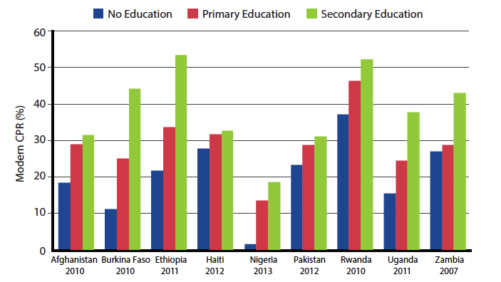
January includes the Intl Day of Education. Keeping girls in school and educating them on #familyplanning is a High Impact Practice that benefits children, families, and communities.
https://www.fphighimpactpractices.org/briefs/educating-girls/ #HIPs4FP #educationday
With each year of education, earning power increases by 10%--and that adds up. Learn why keeping girls in school is a #familyplanning High Impact Practice: https://www.fphighimpactpractices.org/briefs/educating-girls/ #HIPs4FP #educationday
Community engagement, economic incentives, better school environments, and access to #familyplanning can all help keep girls in school:
https://www.fphighimpactpractices.org/briefs/educating-girls/ #HIPs4FP #educationday

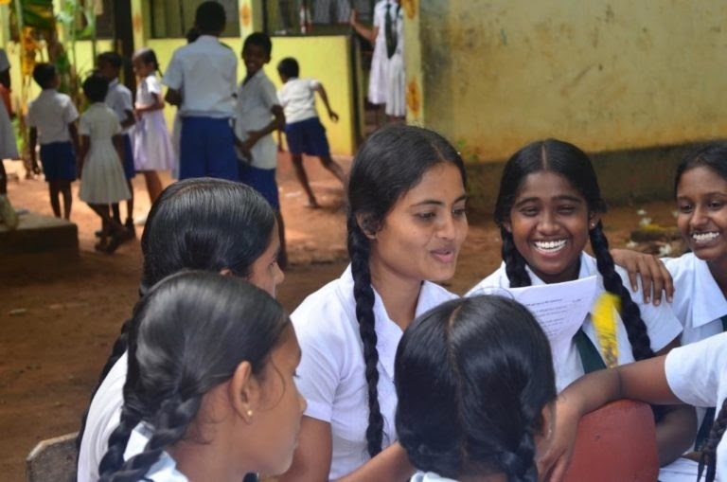
Free uniforms in Kenya, cash transfers in Malawi: learn about the investments that help keep girls in school, contributing to lower dropout and unplanned pregnancy rates:
https://www.fphighimpactpractices.org/briefs/educating-girls/ #HIPs4FP #familyplanning #educationday
Learn how the health sector can help keep girls in school, from policy change to the classroom: https://www.fphighimpactpractices.org/briefs/educating-girls/
#educationday #HIPs4FP #familyplanning
When women are empowered, everyone thrives. Educating girls is associated with better child health outcomes and greater financial stability: https://www.fphighimpactpractices.org/briefs/educating-girls/ #educationday #HIPs4FP #familyplanning
Researchers studied 105 countries and found that investing in universal primary and secondary education helped lift countries out of poverty: https://www.fphighimpactpractices.org/briefs/educating-girls/ #educationday #HIPs4FP #familyplanning

