June 2020

Updated - HIP Supply Chain Management: Investing in the supply chain is critical to achieving family planning goals

Supply Chain Management
Stockouts of popular contraceptive products are common and persistent across many countries. Establishing and maintaining effective supply chain management is essential to making modern contraceptives available and thus helping individuals achieve their reproductive goals. This updated High Impact Practices in Family Planning (HIP) brief, originally published in 2012, focuses on key practices to strengthen the management of each step of the supply chain from the manufacturer to the service delivery point.

Establishing and maintaining effective supply chain management is one of several HIPs identified by a technical advisory group of international experts. Investing in supply chain management by increasing data visibility and use, accelerating product flow, professionalizing the workforce, and capitalizing on private sector capacity are interventions that global health supply chain experts agree will strengthen supply chain capacity and performance.

Download the HIP Supply Chain Management brief and visit www.fphighimpactpractices.org to learn more about High Impact Practices in Family Planning.
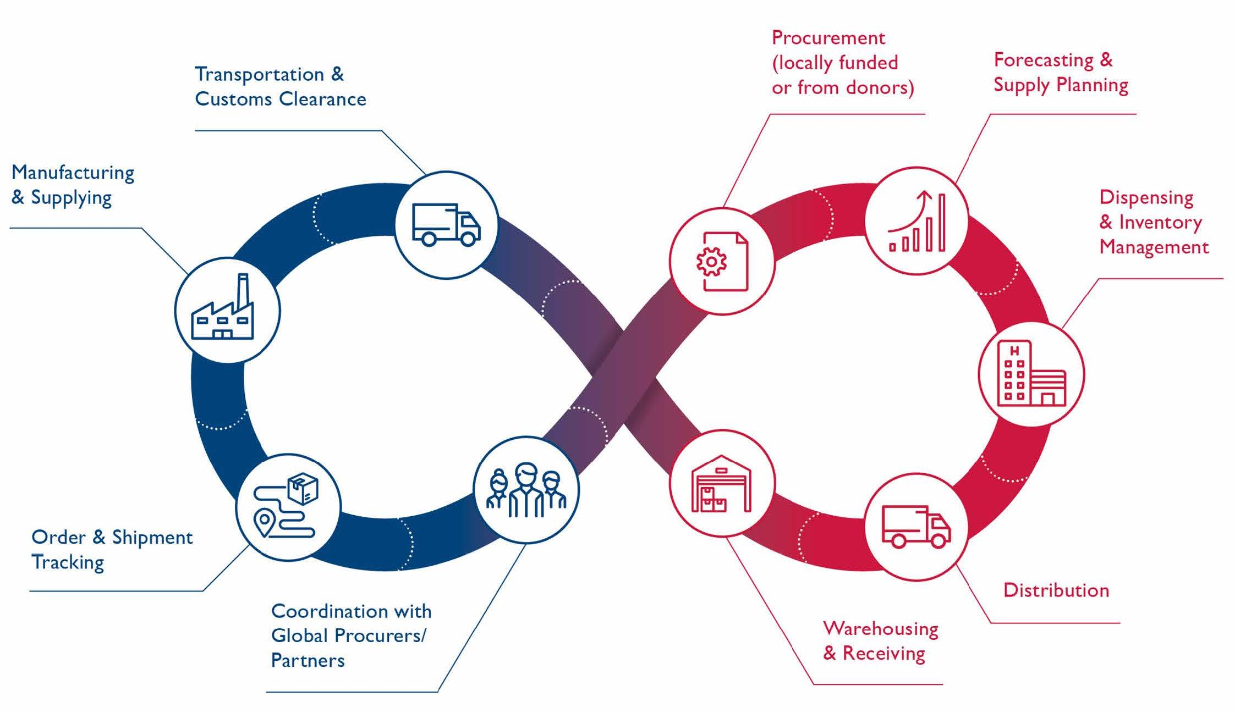
The various processes in the supply chain, from the service delivery point to warehouses to manufacturers, are linked in the “end to end” supply chain. Source: Reproductive Health Supplies Coalition

Key points: Supply Chain Management: Investing in the supply chain is critical to achieving family planning goals
- Inadequate supplies of family planning commodities are estimated to account for up to one-third of the unmet need for family planning in LMICs.
- Establishing and maintaining effective supply chain management is essential to making modern contraceptives available and thus helping individuals achieve their reproductive goals.
- Contraceptive use is higher in contexts with a consistent supply of contraceptive method options. Data from East Africa indicate that a woman living in a region with one additional contraceptive method available in her region was 50% more likely to report using contraception than a woman living in a region with less choice.
- Investing in supply chain management by increasing data visibility and use, accelerating product flow, professionalizing the workforce, and capitalizing on private sector capacity are interventions that global health supply chain experts agree will strengthen supply chain capacity and performance.

Suggested Tweets for HIP Partners focused on the
Supply Chain Management brief

Quick Content! All Suggested Tweets Ready to be Posted

Tweet me!

- A healthy #supplychain is critical to ensuring #familyplanning availability--never more so than during the #COVID19 pandemic. Learn more: https://www.fphighimpactpractices.org/briefs/supply-chain-management/ #HIPs4FP
- How can #familyplanning programs end #stockouts? #supplychain management is essential: https://www.fphighimpactpractices.org/briefs/supply-chain-management/ #HIPs4FP
- Use of #familyplanning is higher when supply is consistent and clients don't need to worry about #stockouts. Learn more about how to nurture a healthy #supplychain: https://www.fphighimpactpractices.org/briefs/supply-chain-management/ #HIPs4FP
- In a crisis like #COVID19, #stockouts can occur and leave #familyplanning clients without their method. Learn how investing in #supplychain management can help: https://www.fphighimpactpractices.org/briefs/supply-chain-management/ #HIPs4FP
- Investing in a strong #familyplanning #supplychain benefits #healthworkers as well as clients. Learn why and how: https://www.fphighimpactpractices.org/briefs/supply-chain-management/ #HIPs4FP
- #familyplanning #stockouts in Senegal dropped from over 80% to less than 2% thanks to a distribution outsourcing strategy. Learn more about #supplychain management: https://www.fphighimpactpractices.org/briefs/supply-chain-management/ #HIPs4FP
- The #familyplanning #supplychain isn’t a straight line. It’s more interlinked than you may realize! Learn more: https://www.fphighimpactpractices.org/briefs/supply-chain-management/ #HIPs4FP

Images designed for social media use: