September 2020

Suggested Tweets for HIP Partners focused on #WCD2020

Quick Content! All Suggested Tweets Ready to be Posted

Monthly, we send you an updated social media guide on the High Impact Practices in Family Planning (HIPs) with the purpose of (1) increasing awareness and use of the HIP briefs, and (2) generating traffic on the HIP website. Please share!

Tweet me!

Ready for #WorldContraceptionDay? #HIPs4FP has you covered for proven #familyplanning practices that increase program impact. https://www.fphighimpactpractices.org/briefs/ #WCD2020
Did you know that 24 months is considered a healthy interval between pregnancies for mothers and their babies? Learn more about immediate postpartum #familyplanning: https://www.fphighimpactpractices.org/briefs/immediate-postpartum-family-planning/ #HIPs4FP #WCD2020
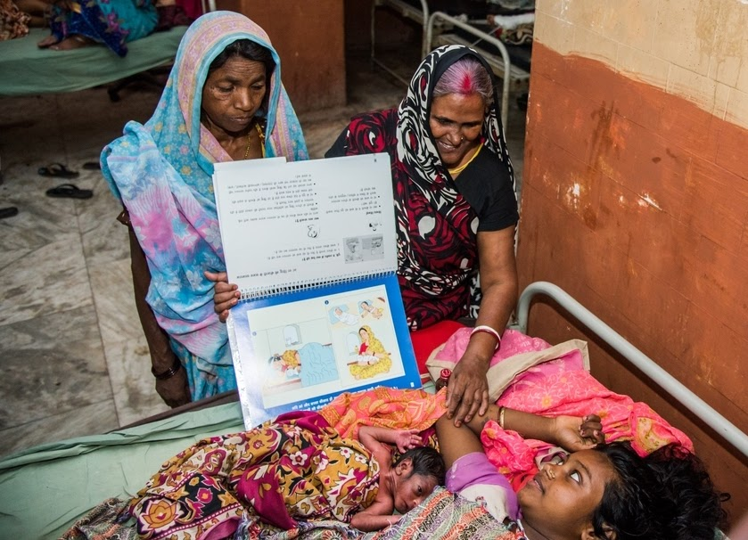
© Bill & Melinda Gates Foundation/Ryan Lobo
Mobile outreach is just one of over a dozen #HIPs4FP to improve #familyplanning programs. More clients, expanded method choice (inc. #LARCs): the data is clear. https://www.fphighimpactpractices.org/briefs/mobile-outreach-services/ #WCD2020
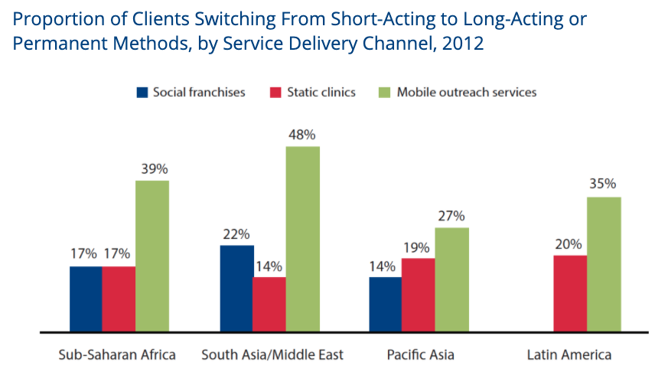
#HIPs4FP are evidence-based, proven by experts, and easy to use. Maximize your #familyplanning program impact, on #WorldContraceptionDay and every day. https://www.fphighimpactpractices.org/briefs/ #WCD2020
“Is there a #familyplanning high-impact practice for that?” Probably! The list of #HIPs4FP grows as new interventions are vetted by a team of experts: https://www.fphighimpactpractices.org/high-impact-practices-in-family-planning-list/ #WorldContraceptionDay #WCD2020
#HIPs4FP webinars (many in French) are a great way to learn about how other #familyplanning programs use each of the HIPs. Connect with others and share your successes:
https://www.fphighimpactpractices.org/hip-webinars/ #WorldContraceptionDay #WCD2020
Did you know that #massmedia is a proven high-impact practice for #familyplanning? Reach a wider audience with accurate health information as part of your strategy: https://www.fphighimpactpractices.org/briefs/mass-media/ #HIPs4FP #WorldContraceptionDay #WCD2020
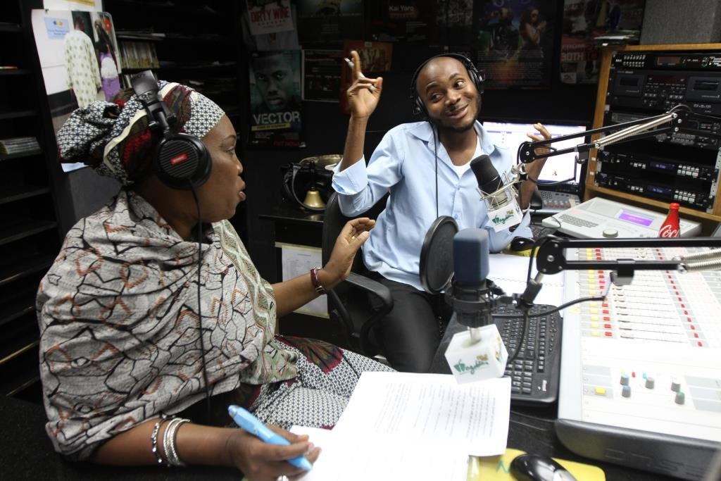
Radio anchor Oche discusses issues with a family planning expert, Mariam Momoh, during a live programme about family planning on Wazobia FM in Abuja, Nigeria. © 2012 Akintunde Akinleye/NURHI, Courtesy of Photoshare
The global #familyplanning community is what makes #HIPs4FP great. Help our work be even better--share your experiences via our new Engagement page: https://www.fphighimpactpractices.org/engage-with-the-hips/ #WorldContraceptionDay #WCD2020
#WorldContraceptionDay is the perfect time to stay up to date with all things #HIPs4FP. Did you know we have a newsletter? https://mailchi.mp/76703a3652c9/hips-newsletter-sign-up #WCD2020 #familyplanning

