February 2021

Suggested Tweets for HIP Partners focused on the
Postabortion Family Planning brief

Quick Content! All Suggested Tweets Ready to be Posted

Monthly, we send you an updated social media guide on the High Impact Practices in Family Planning (HIPs) with the purpose of (1) increasing awareness and use of the HIP briefs, and (2) generating traffic on the HIP website. Please share!

Tweet me!

Did you know that offering voluntary contraceptive counseling/services at the same time & location where women receive postabortion care is a PROVEN high-impact practice for #familyplanning? https://www.fphighimpactpractices.org/briefs/postabortion-family-planning/ #HIPs4FP
“If the woman we treat for postabortion complications is there because she could not get contraception, we have failed her. If she leaves w/o #familyplanning, we have failed her twice.” https://www.fphighimpactpractices.org/briefs/postabortion-family-planning/ #HIPs4FP
Why is postabortion #familyplanning so important? It can help clients achieve their reproductive intentions & is likely to provide cost savings for women, families, & the health system. https://www.fphighimpactpractices.org/briefs/postabortion-family-planning/ #HIPs4FP
Many health workers don’t realize that postabortion clients are at risk of pregnancy almost immediately. Learn why postabortion #familyplanning is so important: https://www.fphighimpactpractices.org/briefs/postabortion-family-planning/ #HIPs4FP
Allowing nurses & midwives to provide postabortion care can expand #familyplanning access & reduce costs. Several countries have demonstrated safety & efficacy: https://www.fphighimpactpractices.org/briefs/postabortion-family-planning/ #HIPs4FP
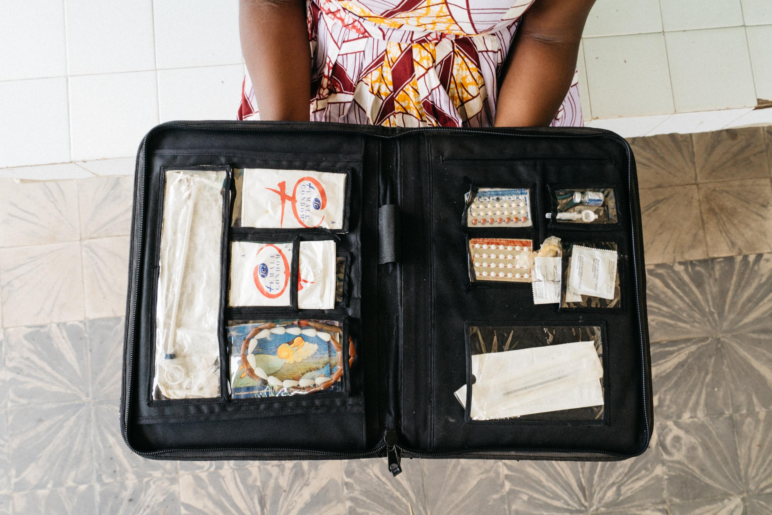
A woman holds a family planning display case containing a mix of contraception options. © 2016 PATH/Gabe Bienczycki, Courtesy of Photoshare
What makes postabortion #familyplanning a High Impact Practice? Data shows that FP acceptance is high when women are offered counseling & services as part of postabortion care. https://www.fphighimpactpractices.org/briefs/postabortion-family-planning/ #HIPs4FP
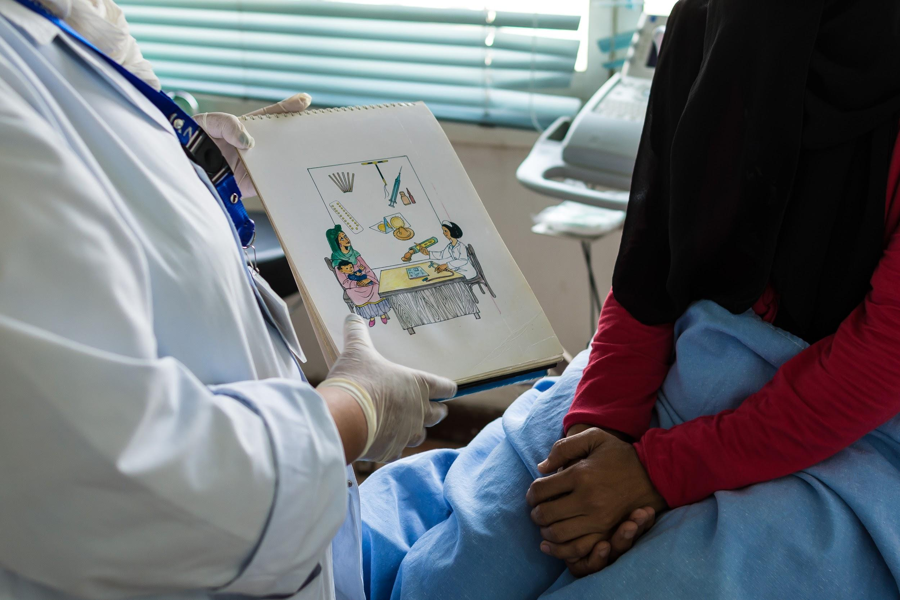
Photo: UNFPA
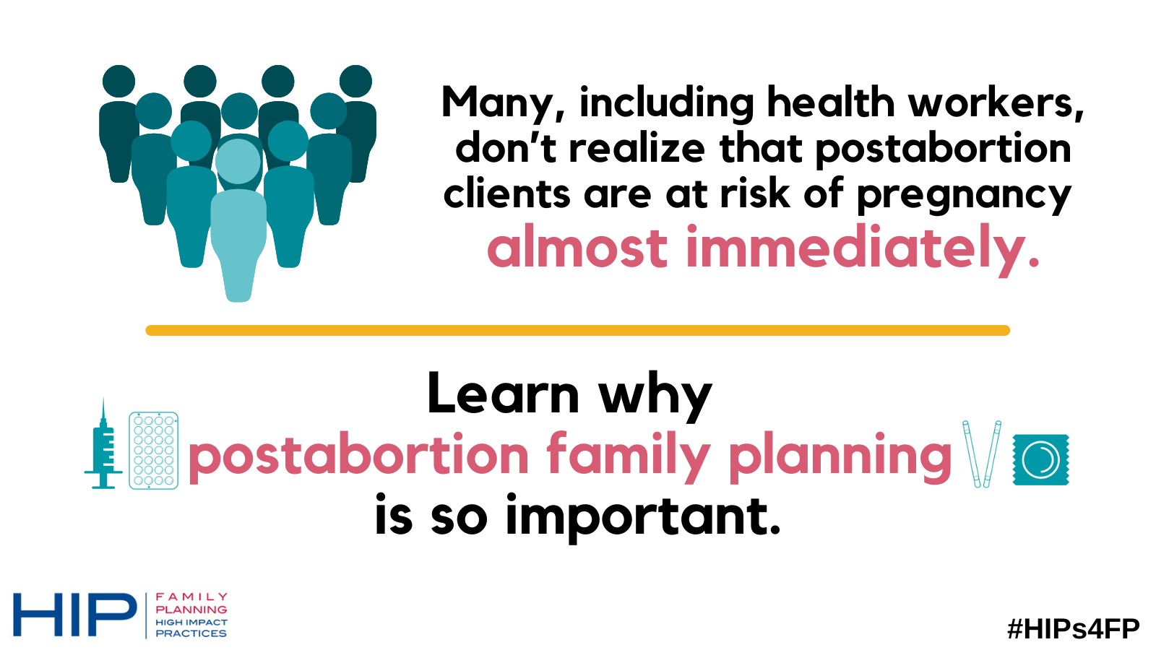
Join the HIP Partnership! #HIPs4FP depends on the #familyplanning expertise and contributions of partner orgs. Learn more:
https://docs.google.com/forms/d/e/1FAIpQLSeXzecvWDlt1fo6d4491TiT1z6IG2DixahVwEbh8oonx_MW6w/viewform
Your #familyplanning expertise helps create stronger #HIPs4FP. Check out the briefs open for community feedback, and share your thoughts: https://www.fphighimpactpractices.org/community-feedback-on-hip-briefs/
As evidence evolves, so do the #HIPs4FP. We need your expert #familyplanning feedback on recently updated briefs! https://www.fphighimpactpractices.org/community-feedback-on-hip-briefs/

