February 2022

Suggested Tweets and Posts for HIP Partners focus on the Supply Chain Management brief

Quick Content! All Suggested Posts Ready to be Posted

Monthly, we send you an updated social media guide on the High Impact Practices in Family Planning (HIPs) with the purpose of (1) increasing awareness and use of the HIP briefs, and (2) generating traffic on the HIP website. Beginning in October 2021, we started including posts for sharing on LinkedIn. Please share!

A few months after the COVID-19 pandemic hit and our community felt the effects on the family planning commodity supply chain, we shared tweets focusing on the Supply Chain Management brief. During a crisis like COVID-19, stockouts can occur more often and leave family planning clients without their chosen method, or any method at all. Now with the Omicron variant and an additional 18 months of supply chain disruptions and other economic impacts from the virus, we are revamping these social media messages for this month. As a refresher, here are a few quick facts about the Supply Chain Management brief:

Supply Chain Management: Investing in the supply chain is critical to achieving family planning goals
- Inadequate supplies of family planning commodities are estimated to account for up to one-third of the unmet need for family planning in low and middle-income countries.
- Establishing and maintaining effective supply chain management is essential to making modern contraceptives available and thus helping individuals achieve their reproductive goals.
- Contraceptive use is higher in contexts with a consistent supply of contraceptive method options. Data from East Africa indicate that a woman living in a region with one additional contraceptive method available in her region was 50% more likely to report using contraception than a woman living in a region with less choice.
- Global health supply chain experts agree that supply chain capacity and performance can be strengthened by investing in supply chain management by increasing data visibility and use, accelerating product flow, professionalizing the workforce, and capitalizing on private sector capacity.

Tweet me!

A healthy #SupplyChain is critical to ensuring #FamilyPlanning availability--never more so than during #omicron. Learn more: https://www.fphighimpactpractices.org/briefs/supply-chain-management/ #HIPs4FP
How can #FamilyPlanning programs end #stockouts? #SupplyChain management is essential: https://www.fphighimpactpractices.org/briefs/supply-chain-management/ #HIPs4FP
Use of #FamilyPlanning is higher when supply is consistent and clients don't need to worry about #stockouts. Learn more about how to nurture a healthy #SupplyChain: https://www.fphighimpactpractices.org/briefs/supply-chain-management/ #HIPs4FP
In a crisis like #COVID19, #stockouts can occur and leave #FamilyPlanning clients without their method. Learn how investing in #SupplyChain management can help: https://www.fphighimpactpractices.org/briefs/supply-chain-management/ #HIPs4FP
The #FamilyPlanning #SupplyChain isn’t a straight line. It’s more interlinked than you may realize! And there are a lot of ways it gets affected with COVID-19 disruptions. Learn more: https://bit.ly/3KUN22r #HIPs4FP

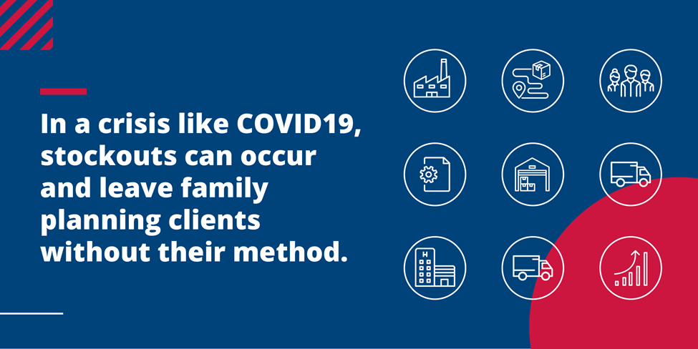
LinkedIn post

During a crisis like COVID-19, stockouts can occur more often and leave family planning clients without their chosen method, or any method at all. Now with the #Omicron variant and an additional #SupplyChain disruptions and other economic impacts from the virus, ensuring a healthy supply chain of family planning commodities is even more critical to achieve family planning goals. Learn more and read some tips in the #HIPs4FP Supply Chain Management brief. Here are some reasons it’s important to invest in the family planning supply chain:
- Inadequate supplies of family planning commodities are estimated to account for up to one-third of the unmet need for family planning in low and middle-income countries.
- Establishing and maintaining effective supply chain management is essential to making modern contraceptives available and thus helping individuals achieve their reproductive goals.
- Contraceptive use is higher in contexts with a consistent supply of contraceptive method options. Data from East Africa indicate that a woman living in a region with one additional contraceptive method available in her region was 50% more likely to report using contraception than a woman living in a region with less choice.
- Global health supply chain experts agree that supply chain capacity and performance can be strengthened by investing in supply chain management by increasing data visibility and use, accelerating product flow, professionalizing the workforce, and capitalizing on private sector capacity.
Read more: https://bit.ly/3KUN22r #HIPs4FP

Social Media Graphics:
