December 2019

Suggested Tweets for HIP Partners focused on the Social Franchising brief

Quick Content! All Suggested Tweets Ready to be Posted

Monthly, we send you an updated social media guide on the High Impact Practices in Family Planning (HIPs) with the purpose of (1) increasing awareness and use of the HIP briefs, and (2) generating traffic on the HIP website. Please share!

Tweet me!

Even though private providers are a common source of #familyplanning services,
many do not offer a full range of methods. Social franchising can change that, with better outcomes for everyone. https://www.fphighimpactpractices.org/briefs/social-franchising/ #HIPs4FP

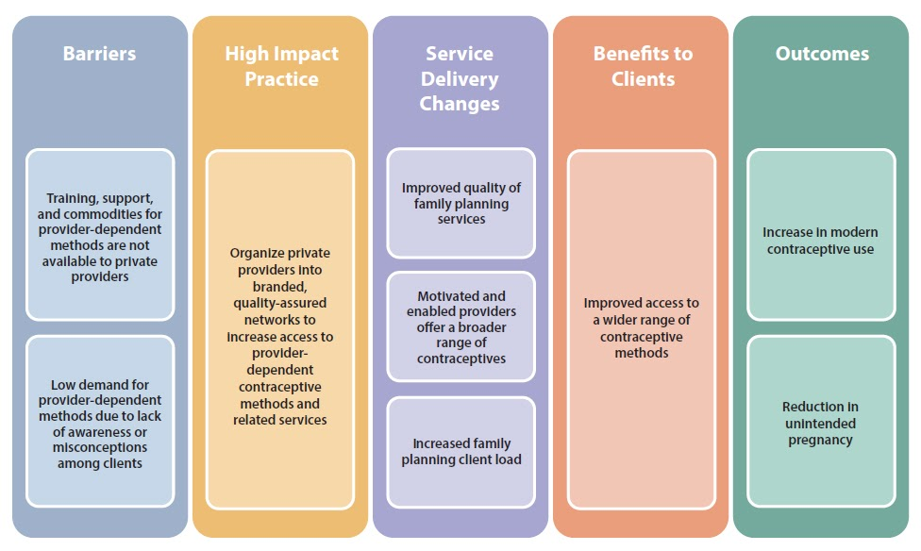
This month, we observe #HumanRightsDay. Increasing equity in health and #familyplanning is a crucial part of achieving human rights for all. https://www.fphighimpactpractices.org/wp-content/uploads/2019/10/HIP-Equity-Discussion-Paper.pdf #StandUp4HumanRights #HIPs4FP
Looking for a High Impact Practice to improve quality AND expand #familyplanning choice in the private sector? Learn more about social franchising, where providers network under a common brand: https://www.fphighimpactpractices.org/briefs/social-franchising/ #HIPs4FP
Social franchising for #familyplanning benefits not only clients, but providers too. Clinics in Myanmar and Vietnam saw an increase of approximately 40% after joining a network. Learn more about this promising high-impact practice: https://www.fphighimpactpractices.org/briefs/social-franchising/ #HIPs4FP

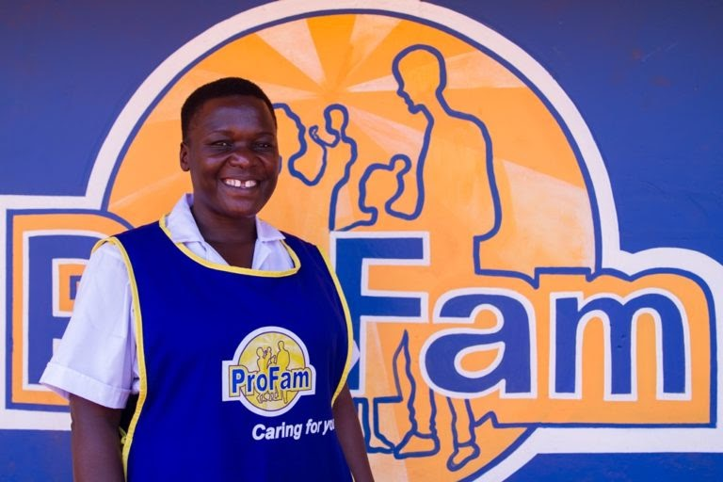
In Kenya and Madagascar, social franchising helped private providers incorporate adolescent-friendly contraceptive services. Including youth in marketing strategies can increase #familyplanning use and expand the method mix. https://www.fphighimpactpractices.org/briefs/social-franchising/ #HIPs4FP
Universal Health Coverage Day may have passed, but #HealthforAll requires year-round effort. Social franchising helps connect independent private providers with public health systems in support of goals like #UHC. https://www.fphighimpactpractices.org/briefs/social-franchising/ #UHCDay #HIPs4FP
APPLY TODAY! Join the work of the #HIPs4FP partnership. Learn more: https://www.fphighimpactpractices.org/hip-technical-expert-application-form/
Are you a #familyplanning expert? Are you interested in contributing to high impact practices for #familyplanning? We have an opportunity for you! #HIPs4FP Learn more: https://www.fphighimpactpractices.org/hip-technical-expert-application-form/

