November 2019

Suggested Tweets for HIP Partners focused on the Supply Chain Management brief

Quick Content! All Suggested Tweets Ready to be Posted

Monthly, we send you an updated social media guide on the High Impact Practices in Family Planning (HIPs) with the purpose of (1) increasing awareness and use of the HIP briefs, and (2) generating traffic on the HIP website. Please share!

Tweet me!

FACT: WHO estimates that about ⅓ of the world’s population lacks regular access to essential medicines, which include contraceptives. SOLUTION: Supply chain management and the #HIPs4FP has a handy brief for that. Check it out: http://bit.ly/SCM4FamPlan 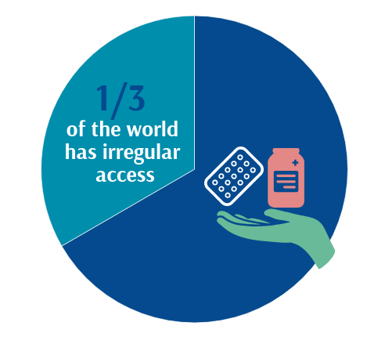
Improvements to supply chain can enhance the quality of care and #familyplanning method choice. This high impact practice reduces stockouts of contraceptives and related equipment necessary to offer long-acting and permanent methods. Find out more: http://bit.ly/SCM4FamPlan #HIPs4FP
In Rwanda, strong govt commitment to #familyplanning and the supply chain contributed to a significant decline in stockout rates of implants from 37% in 2004 to 3% in 2011. Find out more about this high impact practice for #familyplanning: http://bit.ly/SCM4FamPlan #HIPs4FP 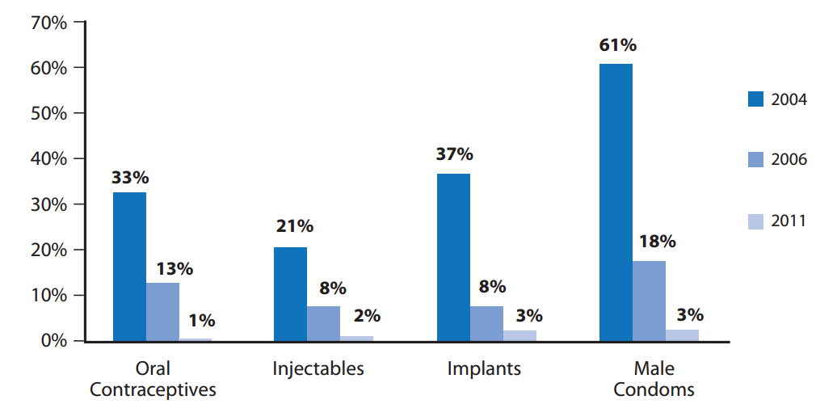
In Zimbabwe, govt and partners implemented a delivery approach used successfully in the commercial sector called the “Delivery Team Topping Up” system to improve the public-sector #familyplanning supply chain. Learn more about this approach: http://bit.ly/SCM4FamPlan #HIPs4FP
Did you know that data indicates that countries with good public-sector logistics systems have higher use of modern contraceptives? Get more familiar with this high impact practice for #familyplanning: http://bit.ly/SCM4FamPlan #HIPs4FP
Interested in becoming more involved in #HIPs4FP and #IBPNetwork? Join the upcoming joint partners meeting on Dec 5th! Virtual attendance information will be circulated. Register today: http://bit.ly/2CFwOs3
REGISTER: Attend the HIP/IBP Joint Partners Meeting on Dec 5th. Virtual participation will be offered. http://bit.ly/2CFwOs3 #HIPs4FP #IBPNetwork

