May 2021

Suggested Tweets for HIP Partners focused on the
Dissemination and Engagement

Quick Content! All Suggested Tweets Ready to be Posted

Monthly, we send you an updated social media guide on the High Impact Practices in Family Planning (HIPs) with the purpose of (1) increasing awareness and use of the HIP briefs, and (2) generating traffic on the HIP website. Please share!

Tweet me!

After birth, the recommended time before attempting another pregnancy is at least 24 months. That’s why immediate postpartum #familyplanning is so important to reduce the risk of adverse health outcomes for mother & baby. Learn more about this #HIPs4FP: https://www.fphighimpactpractices.org/briefs/immediate-postpartum-family-planning/
Did you know immediately after birth, women can choose from a variety of contraceptives including certain hormonal and non-hormonal, long- & short-acting, and permanent methods? Learn more about immediate postpartum #familyplanning in the #HIPs4FP brief:
https://www.fphighimpactpractices.org/briefs/immediate-postpartum-family-planning/
Findings of immediate postpartum #familyplanning studies show that if women are provided comprehensive counseling & proactively offered contraception from a range of choices during childbirth care, between 20-50% will leave with a method. #HIPs4FP https://www.fphighimpactpractices.org/briefs/immediate-postpartum-family-planning/
Need tips for implementing an immediate postpartum #familyplanning program? #HIPs4FP has them. Learn more here: https://www.fphighimpactpractices.org/briefs/immediate-postpartum-family-planning/

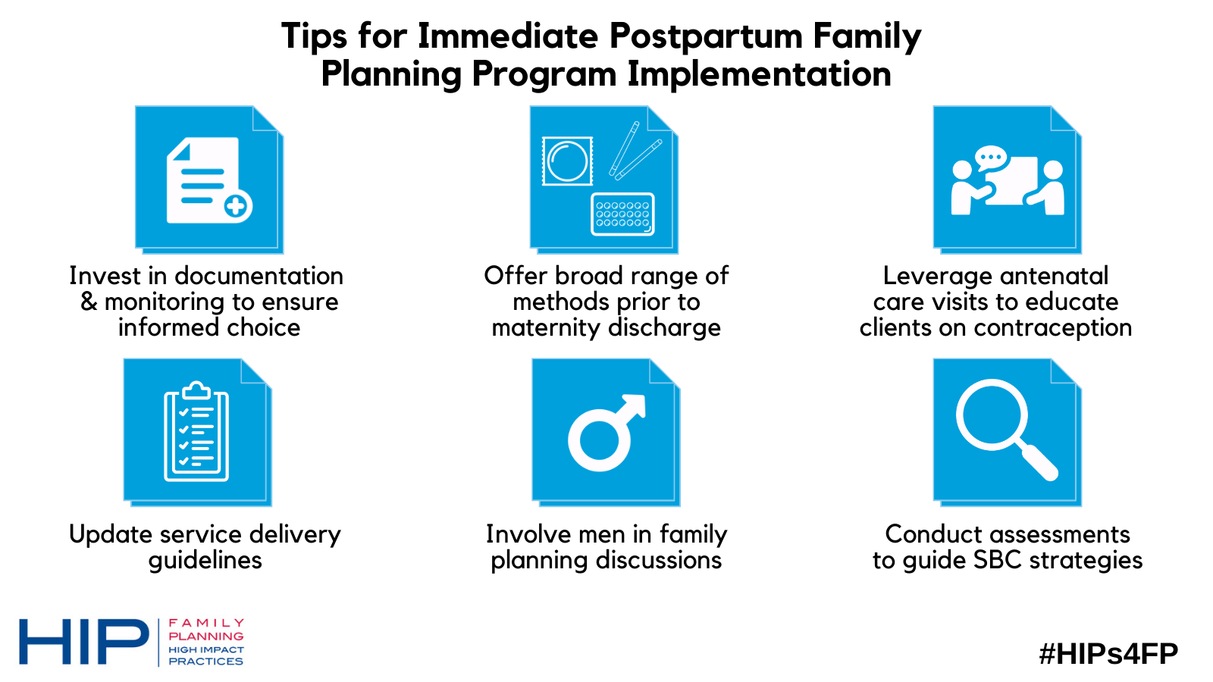

The #HIPs4FP Partnership has doubled the number of supporting partner organizations this year! Check out the impressive list of partners from around the globe 🌍. https://www.fphighimpactpractices.org/partners/

