October 2021

Suggested Tweets for HIP Partners focused on the newly updated Social Marketing Brief

Quick Content! All Suggested Tweets + Posts Ready to be Posted

Monthly, we send you an updated social media guide on the High Impact Practices in Family Planning (HIPs) with the purpose of (1) increasing awareness and use of the HIP briefs, and (2) generating traffic on the HIP website. Beginning in October 2021, we will be sharing posts prepared specifically for sharing on LinkedIn. Please share!

This month’s social media posts are focused on the newly updated Social Marketing brief. For more information on this new product, please read below

The HIP Partnership is pleased to announce the release of the updated Social Marketing brief. An update from the version originally released in 2013, this service delivery brief provides a comprehensive overview of social marketing as it relates to family planning and evidence-based strategies for implementing social marketing practices to maximize family planning investments. Social marketing seeks to leverage marketing concepts to influence behaviors that benefit individuals and communities for the greater social good. It uses behavior change theory, market research, and consumer insight to inform the delivery of health information, products, and services that are attuned to client’s needs, values, and preferences. To do so, social marketing defines its program objectives and utilizes the following four foundational elements of marketing (i.e., the 4 Ps: product, price, promotion, and place) to develop strategies to achieve them. The brief’s Theory of Change presents service delivery changes related to the 4 Ps that can result in improved outcomes, such as increased access to and demand for contraceptive products and services, and tailored solutions that meet the needs of the population.

This brief was written by: Roselline Achola (UNFPA), Norbert De Anda (PSI), Laura Hoemeke, Shawn Malarcher (USAID), Elaine Menotti (USAID), Rachel Mutuku (PSI), Gael O’Sullivan (Georgetown University), Tanvi Pandit-Rajani(JSI), Christina Wakefield (The Manoff Group), and Jane Wickstrom.

Tweet me!

The freshly updated #SocialMarketing brief lays out the 4 Ps of marketing and how these can be used as strategies to increase access to and demand for #contraceptives. Read more at https://www.fphighimpactpractices.org/briefs/social-marketing/ #HIPs4FP
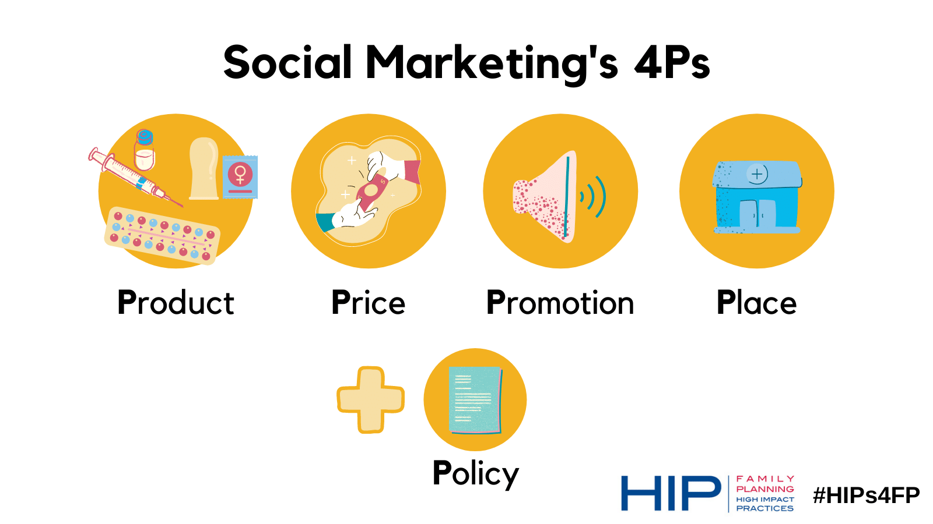
What is #SocialMarketing for family planning? It’s a practice that blends #SocialBehaviorChange and #marketing principles to expand access to and use of #FamilyPlanning services Read the updated HIPs4FP brief: https://www.fphighimpactpractices.org/briefs/social-marketing/

How can you start thinking about planning a #SocialMarketing program? Product, Price, Promotion, Place, + Policy. Find out how these ideas can support your #FamilyPlanning program in the newly updated HIPs4FP brief: https://www.fphighimpactpractices.org/briefs/social-marketing/
Fresh off the press! Find out how you can use #marketing principles and techniques to improve #contraceptive access, choice, and use in the newly updated #HIPs4FP brief: https://www.fphighimpactpractices.org/briefs/social-marketing/
What’s #marketing got to do with #family planning? We’ll tell you in the newly updated #HIPs4FP brief! Read more and find tips for implementation here: https://www.fphighimpactpractices.org/briefs/social-marketing/

LinkedIn

What’s #marketing got to do with #family planning? We’ll tell you in the newly updated #HIPs4FP brief on Social Marketing. This service delivery brief provides a comprehensive overview of social marketing as it relates to family planning and evidence-based strategies for implementing social marketing practices to maximize family planning investments. Social marketing seeks to leverage marketing concepts to influence behaviors that benefit individuals and communities for the greater social good. It uses behavior change theory, market research, and consumer insight to inform the delivery of health information, products, and services that are attuned to client’s needs, values, and preferences.

To do so, social marketing defines its program objectives and utilizes the following four foundational elements of marketing (i.e., the 4 Ps: product, price, promotion, and place) to develop strategies to achieve them. The brief’s Theory of Change presents service delivery changes related to the 4 Ps that can result in improved outcomes, such as increased access to and demand for contraceptive products and services, and tailored solutions that meet the needs of the population. Read more at: https://www.fphighimpactpractices.org/briefs/social-marketing/

This brief was written by: Roselline Achola (UNFPA), Norbert De Anda (PSI), Laura Hoemeke, Shawn Malarcher (USAID), Elaine Menotti (USAID), Rachel Mutuku (PSI), Gael O’Sullivan (Georgetown University), Tanvi Pandit-Rajani(JSI), Christina Wakefield (The Manoff Group), and Jane Wickstrom.

Graphic

