November 2022

Suggested Tweets for HIP Partners focused on Promoting the HIPs at ICFP 2022 (Pt 3)

Quick Content! All Suggested Tweets Ready to be Posted

Monthly, we send you an updated social media guide on the High Impact Practices in Family Planning (HIPs) with the purpose of (1) increasing awareness and use of the HIP briefs, and (2) generating traffic on the HIP website. Please share!

It’s getting close! The International Conference on Family Planning (ICFP) happens this month! Since we’ve been asking you to help spread awareness and generate excitement about the HIP presence at ICFP 2022, this month is no different. This package has updated information on HIP-related sessions and side events. The HIPs will be highlighted and discussed in several sessions throughout the conference, which you can read more about here: https://icfp2022.org/program-implementation/.

These social media messages are intended to generate excitement about ICFP and the HIP-focused sessions, and encourage people to use the HIPs4FP hashtag during sessions. We also have an exciting invitation to a reception, for which is a specially designed message. We developed a gif that you can use for Twitter or LinkedIn; please download it here.

Tweet me!

It’s almost here! #ICFP2022 is a chance to learn, share, and grow a community with FP/RH colleagues around the world. #HIPs4FP will be doing just that – join us! Read more: https://www.fphighimpactpractices.org/the-hips-at-icfp/

Will you be at #ICFP2022 this month? The #HIPs4FP will be! Sessions will focus on scale-up, enabling environment, demand generation, and monitoring of high impact practices and will be in Eng, Fr, and Spa. Read more: https://www.fphighimpactpractices.org/the-hips-at-icfp/
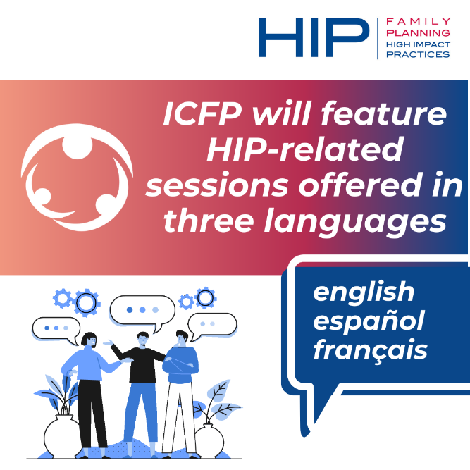

Will you be at #ICFP2022 on Nov 16? Join #HIPs4FP for an evening reception on Scalable #FamilyPlanning Solutions - Register here! https://www.eventbrite.com/e/scalable-family-planning-solutions-high-impact-practices-in-focus-tickets-441067774587
Going to #ICFP2022 in Thailand? Use #HIPs4FP during the conference to share insights and learnings about the high impact practices around the world. https://www.fphighimpactpractices.org/the-hips-at-icfp/
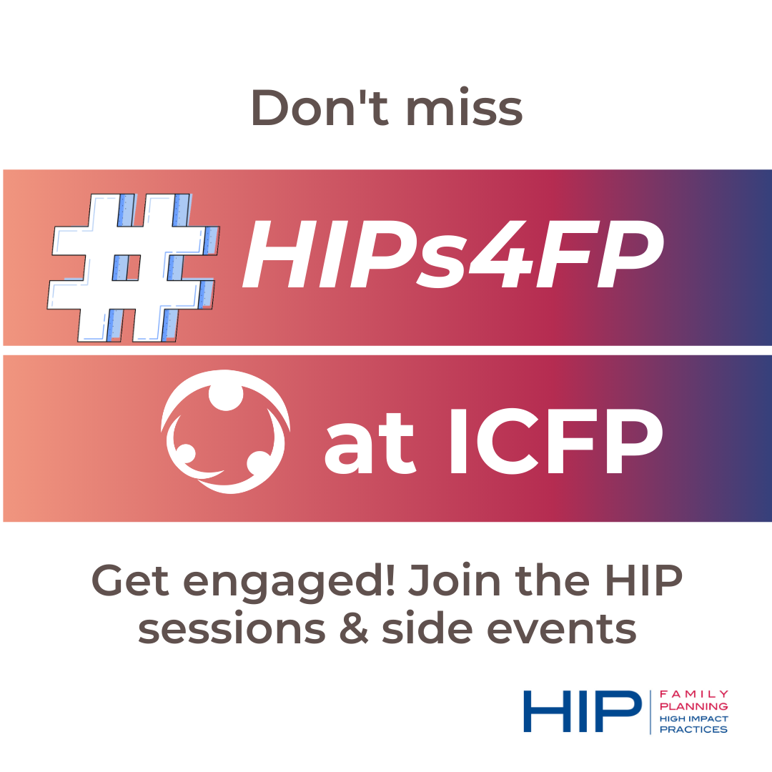
Join #HIPs4FP sessions & events at #ICFP2022 - spread the word! Get ready to learn about service delivery, enabling environment, SBC, demand generation, and implementation & monitoring of high impact practices. Read more: https://www.fphighimpactpractices.org/the-hips-at-icfp/

The theme of #ICFP2022 is #FamilyPlanning and #UHC. #HIPs4FP will be there sharing implementation stories and tools for scale-up and implementation of high impact practices, in pursuit of #UHC. Learn more: https://icfp2022.org/program-implementation/
Join @jhpiego, @USAIDGH, and @PathfinderInt to learn about translating the HIPs into inclusive service delivery at scale in a knowledge cafe style session at #ICFP2022! We can’t wait to see you in Thailand: https://icfp2022.org/program-implementation/ #HIPs4FP
We are looking forward to #ICFP2022, where one session called: “Using the FP Goals: Identifying Opportunities and the Estimated Impact of Different Scale-Up Scenarios” will highlight the #HIPs4FP. Learn more here: https://icfp2022.org/program-implementation/
LinkedIn Post
The International Conference on Family Planning #ICFP2022 (Nov 14 - 17) is almost here! Will you be in Thailand for the conference? The High Impact Practices #HIPs4FP will be! In the face of disruptions to health services, supply chains, and #FamilyPlanning programming, implementers have adapted #HIPs4FP to overcome challenges, fit local contexts & norms, and improve their programs. These stories and learnings will be highlighted at #ICFP2022 and link the #HIPs4HP to the pursuit of #UHC. Don't miss it! Use #HIPs4FP during the conference to share insights and learnings about the HIPs around the world. Sessions will be in English, French, and Spanish. Read more here: https://www.fphighimpactpractices.org/the-hips-at-icfp/ and check-out this open reception too: https://www.eventbrite.com/e/scalable-family-planning-solutions-high-impact-practices-in-focus-tickets-441067774587

